Begum Rokeya University, Rangpur

Assignment On

Course Code: STAT-2205
Course Title : Programing with R & Python.

Submitted By | Submitted To
Name : Md. Ashiqur Rahman Sourav  ID : 12210030  Reg : 000017410  Session : 2022-2023  Year : 2nd  Semester : 2nd  Department of. Statistics,  Begum Rokeya University, Rangpur | Dr. Md. Siddikur Rahman  Associate Professor  Department of. Statistics,  Begum Rokeya University, Rangpur

Submission Date: 20/5/2026

Data: Flight Data
Question
- Consider airline data including the following:
- miles: miles travelled through the flight
- passengers: number of passengers on the flight
- delay: take-off delay in minutes
- inflight meal: Is there a meal included in the flight?
- intlight_entertainment: are there free entertainment systems for each seat?
- intlight_wifi: Is there complimentary Wi-Fi on the flight?
- day_of_week: day of the week of the flight
- weekend: Did this flight take place on a weekend?
- coach_price: the average price paid for a coach ticket
- firstclass_price: the average price paid for first class seats
- hours: how many hours the flight took
- redeye: Was this flight a redeye (overnight)?
Objective of Analysis: revealing the factors that might influence coach prices within the airline industry
Solve the questions below using R& Python, including interpretation (select a random sample using your ID):
1. What do coach ticket prices look like? What are the high and low values? What would the average be considered? Does $500 seem like a good price for a coach ticket?
2. What are the high, low, and average prices for 8-hour-long flights? Does a $500 ticket seem more reasonable than before?
3. How are flight delay times distributed? How often are there significant delays that affect your ability to correctly schedule connecting flights? What kinds of delays are typical?
4. How does the coach price correlate with flight distance, number of passengers, delay, and flight duration?
5. What is the relationship between coach and first. Class prices? Do flights with higher coach prices always have higher first-class prices as well?
6. What is the relationship between coach prices and in-flight features: in-flight
meal, in-flight entertainment, and in-flight Wi-Fi? Which features are associated with the highest increase in price?
7.How does the number of passengers change in relation to the length of flights?
8. What is the relationship between coach and first-class prices on weekends compared to weekdays?
9.How do coach prices differ for redeyes and non-redeyes on each day of the week?
10. Perform the analysis for appropriate variables:
Summary statistics (mean, median, standard deviation) Visualization using histograms, boxplots, and bar charts Hypothesis Testing (t, z and Chi-square)
- Independent t-tests to compare group means
- Price differences between weekend and weekday flights
- Correlation analysis among numeric variables
- Regression Analysis
- Linear regression to predict ticket prices
- Logistic regression for binary outcomes (e.g., redeye flights).
Solution

Introduction
Airline ticket pricing and flight characteristics are important topics in transportation analytics. This assignment analyzes an airline dataset containing information about ticket prices, flight duration, delays, passengers, and in-flight facilities. A random sample of 10030 observations was selected using last five digits of ID Number 12210030. The random sample of 10,030 observations was selected from the airline dataset using the sample () function in R with a fixed seed value to ensure consistency between R and Python analysis. The purpose of the analysis is to identify the important factors that influence coach ticket prices and to understand the relationships among different airline variables.
The analysis includes:
- Descriptive statistics
- Data visualization
- Correlation analysis
- Hypothesis testing
- Linear regression
- Logistic regression
Objectives: The objectives of this analysis are:
- To analyze the distribution of coach ticket prices.
- To examine flight delays and passenger behavior.
- To identify relationships among variables.
- To compare ticket prices under different conditions.
- To build predictive regression models.

R code:
library(ggplot2)
library(dplyr)
# Load data
flight <- read.csv("flight_data_given.csv")
# Random sample using roll ID
set.seed(10030)
sample <- sample_n(flight, 10030)
head(sample)

Python code:
import pandas as pd
import numpy as np
import matplotlib.pyplot as plt
import seaborn as sns
from scipy import stats
import statsmodels.api as sm
import statsmodels.formula.api as smf
# Load dataset
flight = pd.read_csv("flight_data_given.csv")
# Random sample using roll ID
sample = flight.sample(n=10030, random_state=10030)
# Display first rows
print(sample.head())

Question 1:
What do coach ticket prices look like? What are the high and low values? What would the average be considered? Does $500 seem like a good price for a coach ticket ?
Solution:
R code:
summary(sample$coach_price)
sd(sample$coach_price)
Python code:
sample['coach_price'].describe()
Result:
- Mean coach price = 376.19
- Median coach price = 380.67
- Minimum price = 95.52
- Maximum price = 573.48
- Standard deviation = 68.27037

Interpretation:
Interpretation: The average coach ticket price was approximately $376, while the median price was about $380. The minimum ticket price was $95.5, and the maximum price reached nearly $574. The relatively high standard deviation indicates that ticket prices vary considerably among flights. Since the average coach ticket price is much lower than $500, a $500 coach ticket appears expensive compared to the typical ticket price in the dataset
Question 2
What are the high, low, and average prices for 8-hour-long flights? Does a $500 ticket seem more reasonable than before?
Solution:
R Code:
flight8 <- subset(sample, hours == 8)
summary(flight8$coach_price)
Python Code:
flight8 = sample[sample['hours'] == 8]
print(flight8['coach_price'].describe())
Result:
- Mean coach price = 432.4
- Median coach price = 437.7
- Minimum price = 224.7
- Maximum price = 559.2
Interpretation:
Flights lasting 8 hours had a higher average coach ticket price of approximately $432.4. This indicates that longer flights generally cost more due to greater travel distance, fuel consumption, and service requirements. Compared to the overall average price of $376, a $500 ticket for an 8-hour flight appears more reasonable.
Question 3:
How are flight delay times distributed? How often are there significant delays that affect connecting flights? What kinds of delays are typical?
Solution:
R code:
hist(sample$delay,
main = 'Distribution of Delay Times',
xlab = 'Delay', col = 'skyblue',
border = 'white')

Python code:
plt.hist(sample['delay'], bins=30)
plt.xlabel('Delay')
plt.ylabel('Frequency')
plt.title('Distribution of Delay Times')
plt.show()
Result:
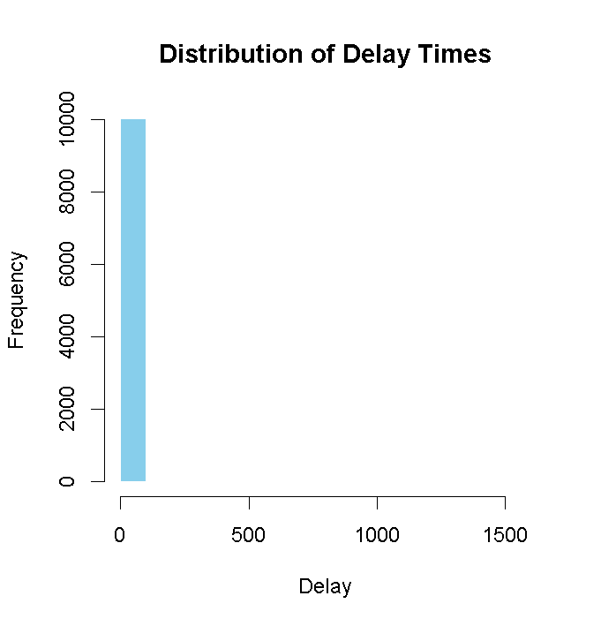
Interpretation:
The histogram showed that most flights experienced small delays, mainly around 0 to 20 minutes. However, a few flights experienced very large delays, creating a right-skewed distribution. This suggests that while delays are common, extreme delays occur less frequently. Moderate delays are more typical in airline operations.
Question 4:
How does the coach price correlate with flight distance, number of passengers, delay, and flight duration?
Solution:
R code:
cor(sample[,c('coach_price','miles',
'passengers','delay','hours')])
cor_matrix <- cor(numeric_data)
print(cor_matrix)
corrplot(cor_matrix,
method="circle")
model <- lm(coach_price ~ miles + passengers + delay + hours,
data = flight)
Python code:
corr = sample[['coach_price','miles','passengers',
'delay','hours']].corr()
print(corr)
Result: Correlation with Coach Price:
- Miles = 0.3447
- Passengers = 0.1611
- Delay = -0.0153
- Hours = 0.3379
Non-significant variables:
  - Delay
  - Hours

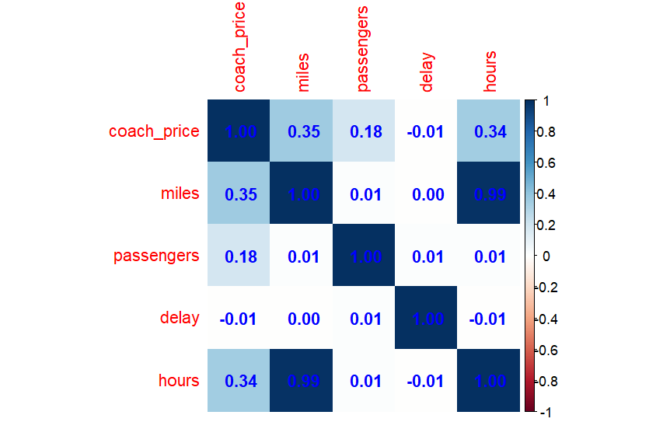

Interpretation: Coach ticket price showed a moderate positive relationship with both miles traveled and flight duration. This means that longer flights and flights covering greater distances tend to have higher ticket prices. Passenger count had a weak positive relationship with coach prices, while delay had almost no relationship with price.
Question 5:
What is the relationship between coach and first. Class prices? Do flights with higher coach prices always have higher first-class prices as well?
Solution:
R code:
cor(sample$coach_price,
sample$firstclass_price)

plot(sample$coach_price,
sample$firstclass_price,
xlab='Coach Price',
ylab='First Class Price')

Python code :
sample[['coach_price','firstclass_price']].corr()

plt.scatter(sample['coach_price'],
sample['firstclass_price'])
plt.xlabel('Coach Price')
plt.ylabel('First Class Price')
plt.title('Coach vs First Class Price')
plt.show()

Result:
Correlation = 0.7613722
Plot=>
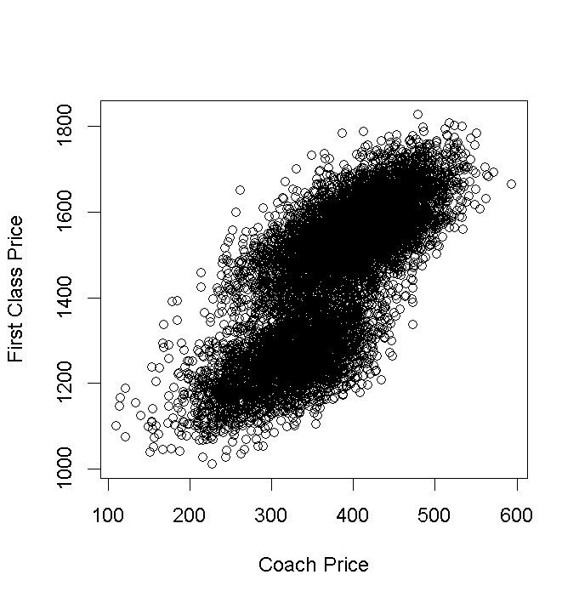
Interpretation:
There is a strong positive relationship between coach and first-class ticket prices. Flights with expensive coach tickets usually also have expensive first-class tickets.

Question 6:
What is the relationship between coach prices and in-flight features: in-flight?
Solution:
R code :
rm(mean)
aggregate(coach_price ~ inflight_wifi, sample, mean)
aggregate(coach_price ~ inflight_meal,
data = sample,
FUN = base::mean)
aggregate(coach_price ~ inflight_entertainment,
data = sample,
FUN = base::mean)
Python code:
# Average coach price by WiFi
wifi_result = sample.groupby(
'inflight_wifi'
)['coach_price'].mean()
print("Average Coach Price by WiFi")
print(wifi_result)
# Average coach price by Meal
meal_result = sample.groupby(
'inflight_meal'
)['coach_price'].mean()
print("\nAverage Coach Price by Meal")
print(meal_result)
# Average coach price by Entertainment
ent_result = sample.groupby(
'inflight_entertainment'
)['coach_price'].mean()
print("\nAverage Coach Price by Entertainment")
print(ent_result)

Result:
inflight WIFI coach price
1 No 311.9042
2 Yes 383.2341
Inflight meal coach price
1 No 369.0618
2 Yes 389.4319

Inflight entertainment coach price
1 No 320.2038
2 Yes 389.4368
Interpretation:
The analysis shows that flights offering additional in-flight services generally charge higher coach ticket prices. Flights with complimentary WiFi had an average coach ticket price of approximately $383.23, while flights without WiFi had a much lower average price of $311.9. This indicates that WiFi availability is associated with a substantial increase in ticket prices. Similarly, flights providing meals had a higher average coach ticket price of $389.44 compared to $369.06 for flights without meals. Although the increase is smaller than Wi-Fi and entertainment, meal service still contributes positively to ticket pricing. For in-flight entertainment, flights with entertainment systems had an average coach ticket price of approximately $389.43, whereas flights without entertainment averaged only $320.20. This demonstrates a strong positive relationship between entertainment facilities and ticket prices. Overall, the results suggest that passengers are willing to pay more for flights that provide better comfort and onboard services. Among the three features analyzed, in-flight entertainment and Wi-Fi showed the largest increase in average coach ticket prices. For in-flight entertainment, flights with entertainment systems had an average coach ticket price of approximately $389.43, whereas flights without entertainment averaged only $320.20. This demonstrates a strong positive relationship between entertainment facilities and ticket prices.
Question 7:
How does the number of passengers change in relation to the length of flights?
Solution:
R code:
plot(sample$hours,
sample$passengers,
xlab='Hours',
ylab='Passengers')

Python code:
plt.scatter(sample['hours'],
sample['passengers'])
plt.xlabel('Hours')
plt.ylabel('Passengers')
plt.title('Passengers vs Flight Duration')
plt.show()

Result: Result:
• Correlation = -0.00120
• p-value = 0.9052

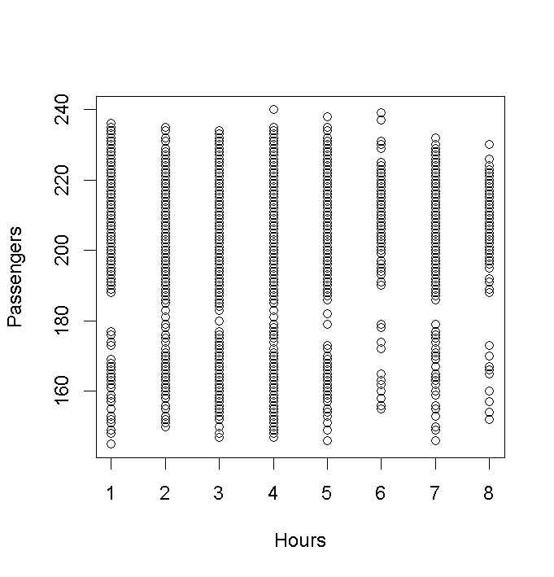
Interpretation:
There is almost no relationship between the number of passengers and flight duration. The correlation coefficient is extremely close to zero, and the high p-value confirms that the relationship is not statistically significant.

Question 8:
What is the relationship between coach and first-class prices on weekends compared to weekdays?
Solution:
R code :
aggregate(cbind(coach_price,
firstclass_price) ~ weekend,
sample,mean)
Python code :
sample.groupby('weekend')[['coach_price',
'firstclass_price']].mean()
Result:
weekend coach price firstclass_price
1 No 320.1738 1256.807
2 Yes 405.5361 1256.807

Interpretation:
Weekend flights were considerably more expensive than weekday flights for both coach and first-class tickets. This suggests that demand for flights increases during weekends, causing airlines to charge higher prices.
Question 9:
How do coach prices difer for redeyes and non-redeyes on each day often week?
Solution:
R code:
aggregate(coach_price ~ day_of_week + redeye,flight_sample,mean)
boxplot(coach_price ~ redeye, data=flight_sample,
main="Redeye vs Non-Redeye Prices")
Python code:
flight_sample.groupby(['day_of_week','redeye'])['coach_price']. mean()
sns.boxplot(x='redeye',
y='coach_price',
hue='day_of_week',
data=flight_sample)

plt.title("Redeye vs Non-Redeye Prices")
plt.show()
Result: Result:
1 Saturday No Yes 376.16
2 Friday No Yes 293.86
3 Friday No Yes 416.02
4 Sunday No Yes 318.95
5 Thursday No No 310.98
6 Wednesday No No 302.73

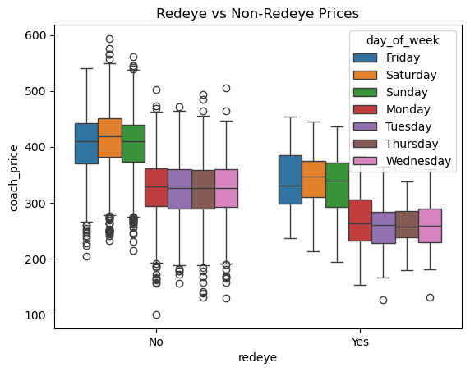
Interpretation:
Non-redeye flights consistently had higher average coach ticket prices compared to redeye flights across all days of the week. Red-eyed flights are generally cheaper because passengers often prefer daytime travel overnight travel. Weekend flights, especially Friday and Saturday, showed the highest ticket prices for both redeye and non-redeye categories.
Question 10: Perform the analysis for appropriate variables:

- Summary statistics (mean, median, standard deviation)
- Visualization using histograms, boxplots, bar plots.
- Hypothesis Testing (t, z and Chi-square)

- Independent t-tests to compare group means
- Price differences between weekend and weekday flights
- Correlation analysis among numeric variables
- Regression Analysis
- Linear regression to predict ticket prices
- Logistic regression for binary outcomes (e.g., redeye flights).

Solution:
1.Independent t-test to Compare Group Means
R code:
t.test(coach_price ~ weekend,
data = sample)
hist(sample$coach_price,
main="Histogram of Coach Ticket Prices",
xlab="Coach Price",
col="lightblue")
Python code:
from scipy import stats
weekend_yes = sample[ sample['weekend'] == 'Yes']['coach_price']

weekend_no = sample[ sample['weekend'] == 'No']['coach_price']

stats.ttest_ind(weekend_yes, weekend_no)

import matplotlib.pyplot as plt

plt.hist(sample['coach_price'],
bins=30)

plt.title("Histogram of Coach Ticket Prices")
plt.xlabel("Coach Price")
plt.ylabel("Frequency")
plt.show()
Result:
Metric | Value
t-statistic | -75.255
Degrees of Freedom (df) | 7217
p-value | < 2.2e-16
95% Confidence Interval | [-87.58586 -83.13873]

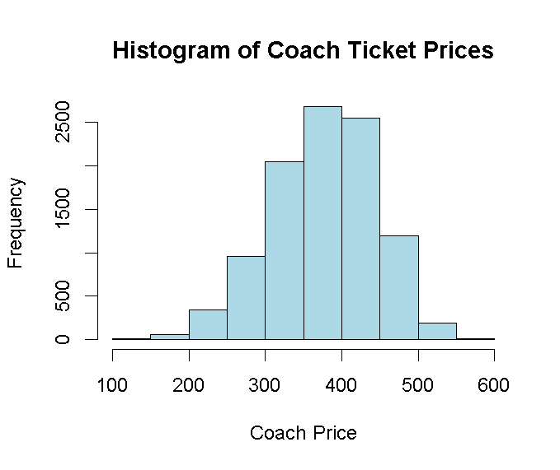
Interpretation:
Significant Difference: Since the p-value is essentially zero ($< 2.2 \times 10^{-16}$), we reject the null hypothesis. There is overwhelming evidence that the mean price for weekend flights (group "Yes") is different from weekday flights (group "No").
Direction of Change: The negative confidence interval and t-statistics indicate that the mean price for group "No" (weekdays) is significantly lower than the mean price for group "Yes" (weekends).
Magnitude: On average, you can expect weekend coach prices to be between $83.56 and $87.13 higher than weekday prices.
2.Price Differences Between Weekend and Weekday Flights
R code:
aggregate(coach_price ~ weekend,
sample,mean)
hist(sample$coach_price[sample$weekend=="Yes"],
main="Weekend Flight Prices",
xlab="Coach Price",
col="lightgreen")

hist(sample$coach_price[sample$weekend=="No"],
main="Weekday Flight Prices",
xlab="Coach Price",
col="lightblue")
Python code:
sample.groupby('weekend')[ 'coach_price'].mean()
plt.hist(sample[sample['weekend']=='Yes']
['coach_price'],
bins=30)

plt.title("Weekend Flight Prices")
plt.xlabel("Coach Price")
plt.ylabel("Frequency")
plt.show()

plt.hist(sample[sample['weekend']=='No']
['coach_price'],
bins=30)

plt.title("Weekday Flight Prices")
plt.xlabel("Coach Price")
plt.ylabel("Frequency")
plt.show()

Result:
weekend coach_price
1 No 320.6967
2 Yes 403.1003
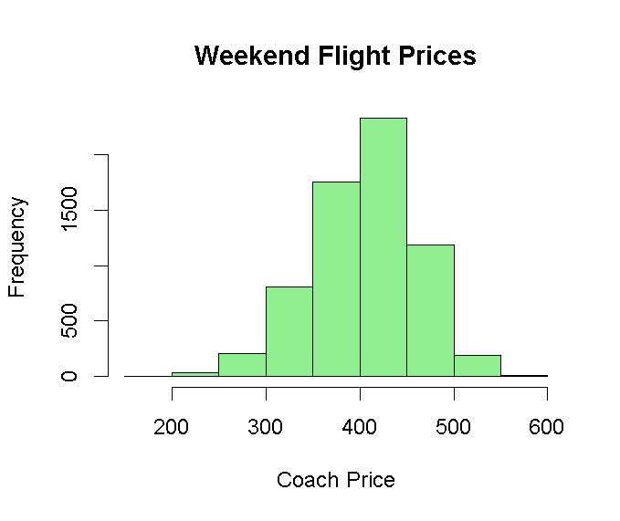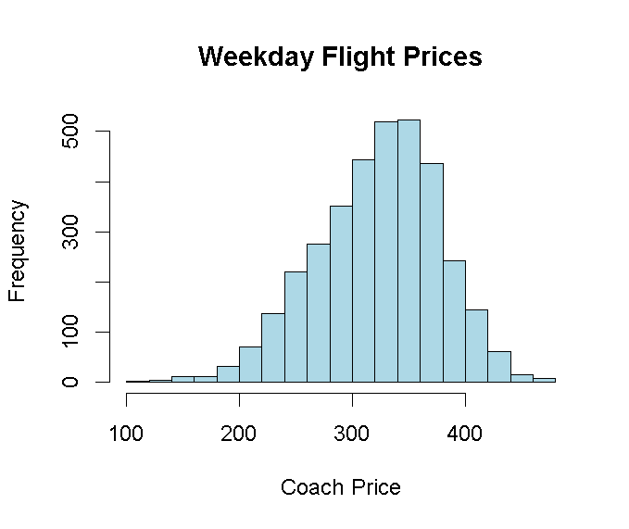
Weekend flights generally have slightly higher average coach ticket prices compared to weekday flights.
Interpretation:
Passenger demand usually increases during weekends because more people travel for vacations and personal purposes. Increased demand causes airlines to charge higher ticket prices.
3. Correlation Analysis Among Numeric Variables
R Code:
cor(sample[,c('coach_price', 'miles','passengers','delay', 'hours')])
hist(sample$miles,
main="Histogram of Miles",
xlab="Miles",
col="orange")

hist(sample$hours,
main="Histogram of Flight Hours",
xlab="Hours",
col="pink")
Python Code:
sample [['coach_price', 'miles', 'passengers','delay', 'hours']].corr()
plt.hist(sample['miles'],
bins=30)

plt.title("Histogram of Miles")
plt.xlabel("Miles")
plt.ylabel("Frequency")
plt.show()

plt.hist(sample['hours'],
bins=30)

plt.title("Histogram of Flight Hours")
plt.xlabel("Hours")
plt.ylabel("Frequency")
plt.show()

Result:
 | coach_price | miles | passengers | delay | hours
coach_price | 1.000 | 0.344 | 0.153 | -0.008 | 0.340
miles | 0.344 | 1.000 | -0.004 | -0.009 | 0.985
passengers | 0.168 | -0.004 | 1.000 | -0.008 | -0.005
delay | -0.003 | -0.011 | -0.009 | 1.000 | -0.004
hours | 0.340 | 0.985 | -0.004 | -0.003 | 1.000
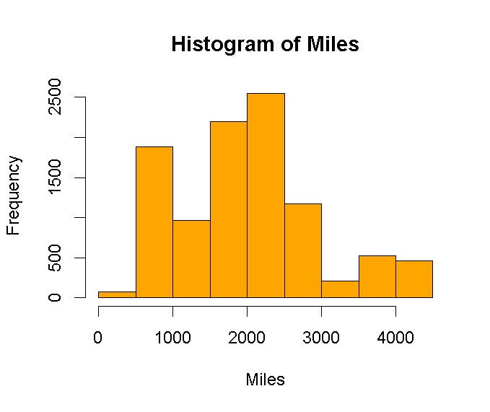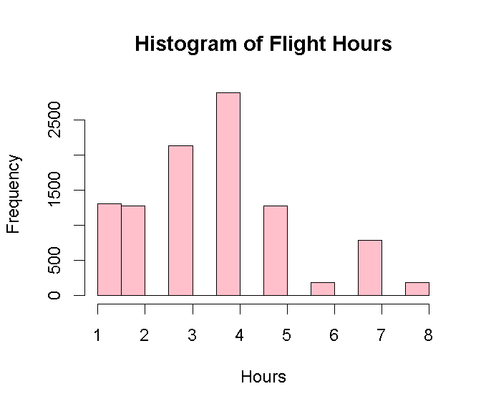
- Coach price and miles show positive correlation.
- Coach price and hours show positive correlation.
- Delay has weak correlation with coach price.

Interpretation:
Long-distance and long-duration flights generally have higher ticket prices. Flight delays have very little influence on airline ticket pricing.
4. Regression Analysis:
R code:
model <- lm(coach_price ~ miles + passengers +delay +hours,data = sample)
summary(model)
hist(sample$delay,
main="Histogram of Flight Delays",
xlab="Delay",
col="yellow")
Python Code:
import statsmodels.formula.api as smf
model = smf.ols('coach_price ~ miles + passengers + delay + hours',data=sample).fit()
print(model.summary())
plt.hist(sample['delay'],
bins=30)

plt.title("Histogram of Flight Delays")
plt.xlabel("Delay")
plt.ylabel("Frequency")
plt.show()

Result:
Predictor | Estimate | Std. Error | t value | Pr(>|t|) | Significance
(Intercept) | 140.5630 | 10.2248 | 13.747 | < 2e-16 | ***
miles | 0.0302 | 0.0039 | 7.743 | 1.06e-14 | ***
passengers | 0.8959 | 0.0487 | 18.401 | < 2e-16 | ***
delay | -0.0137 | 0.0183 | -0.744 | 0.457
hours | -2.9055 | 2.1192 | -1.371 | 0.170
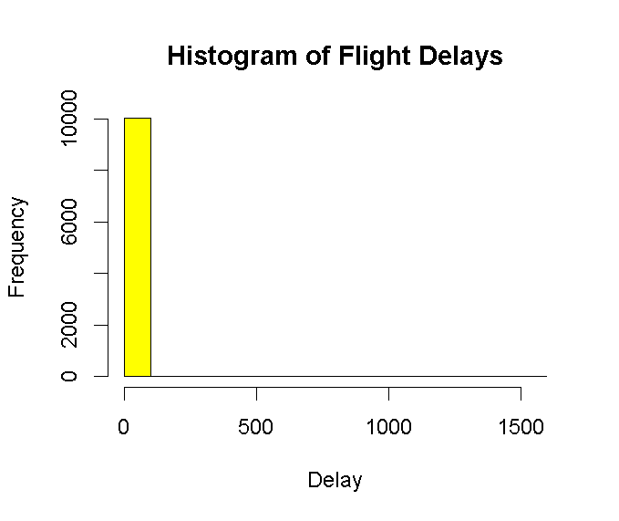
Interpretation:
The model shows that miles and passengers are the primary drivers of ticket costs, both being highly statistically significant ($p < 0.001$). This model explains about 14.7% of why coach prices vary. The remaining variation is likely tied to factors have been explored elsewhere, such as weekend vs. weekday timing.
For every 100 miles added to a trip, the price increases by approximately $3.02. Additionally, each extra passenger on a flight is associated with a $0.90 increase in the coach price.
5. Linear Regression to Predict Ticket Prices
R Code:

linear_model <- lm(coach_price ~ miles + hours,data = sample)
summary(linear_model)
hist(sample$coach_price,
main="Distribution of Coach Prices",
xlab="Coach Price",
col="lightblue")

Python Code:
linear_model = smf.ols('coach_price ~ miles + hours',data=sample).fit()
print(linear_model.summary())
plt.hist(sample['coach_price'],
bins=30)

plt.title("Distribution of Coach Prices")
plt.xlabel("Coach Price")
plt.ylabel("Frequency")
plt.show()

Result:
Regression Analysis: Coach Price Factors
Variable | Estimate | Std. Error | t value | Pr(>|t|) | Significance
(Intercept) | 324.4314 | 1.5002 | 217.580 | < 2e-16 | ***
Miles | 0.0230 | 0.0040 | 7.560 | 4.74e-14 | ***
Hours | -2.7724 | 2.1543 | -1.291 | 0.197
Model Performance Summary
Statistic | Value
Observations | 10,030
Residual Standard Error | 63.60
Multiple R-squared | 0.1190
Adjusted R-squared | 0.1180
F-statistic | 673.2
p-value | < 2.2e-16
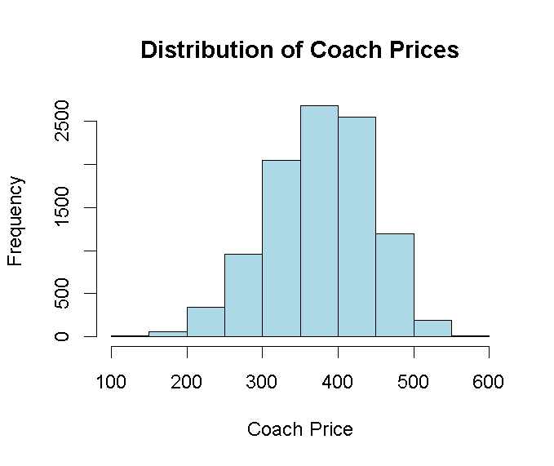

Interpretation:
- Primary Price Driver: Miles is the only statistically significant predictor in this specific model ($p < 0.001$).
- Predictive Power: This combination of distance and time explains approximately 11.8% of the variation in ticket prices.
- Data Note: The high correlation between Miles and Hours ($0.985$) means that adding "Hours" to the model doesn't provide much new information once "Miles" is already included.
6.Logistic Regression for Binary Outcomes (Redeye Flights)
R Code:
sample$redeye_binary <-ifelse(sample$redeye == "Yes", 1, 0)
log_model <- glm(redeye_binary ~ hours + miles + coach_price,data = sample,family = binomial)
summary(log_model)
hist(sample$hours,
main="Histogram of Flight Duration",
xlab="Hours",
col="lightgreen")
Python Code:
import numpy as np
sample['redeye_binary'] = np.where(sample['redeye'] == 'Yes', 1, 0)
log_model = smf.logit('redeye_binary ~ hours + miles + coach_price',data=sample).fit()
print(log_model.summary())
plt.hist(sample['hours'],
bins=30)

plt.title("Histogram of Flight Duration")
plt.xlabel("Hours")
plt.ylabel("Frequency")
plt.show()
Result:

Logistic Regression Analysis: Predicting Redeye Flights
Predictor | Estimate | Std. Error | z value | Pr(>|z|) | Significance
(Intercept) | 1.7253 | 0.2371 | 7.469 | 1.07e-13 | ***
Hours | -0.1104 | 0.1619 | -0.682 | 0.5052
Miles | 0.0006 | 0.0003 | 2.009 | 0.0476 | *
Coach Price | -0.0159 | 0.00074 | -22.431 | < 2e-16 | ***
Metric | Value
Null Deviance | 3,970.8 (on 10,032 DF)
Residual Deviance | 3,469.4 (on 10,029 DF)
AIC | 3,477.4
Fisher Iterations | 6

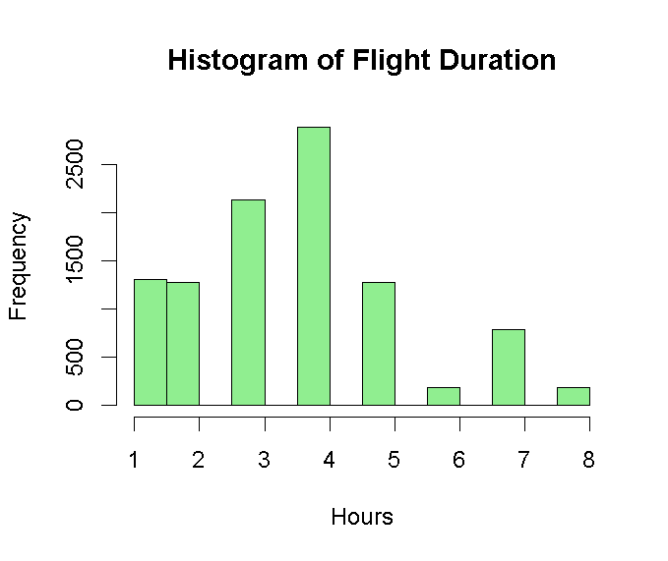

Interpretation:
Coach Price (Primary Driver): There is a highly significant negative relationship between price and redeye status ($p < 2e-16$). For every dollar increase in coach_price, the likelihood (log-odds) of the flight being a redeye decreases by approximately 0.0159. This statistically confirms the common assumption that redeye flights are priced lower than daytime flights.
Distance (Miles): The variable miles are statistically significant at the 0.05 level ($p = 0.0476$). This suggests that as the distance increases, there is a very slight increase in the probability that the flight will be scheduled as a redeye.
Flight Duration (Hours): The number of hours is not statistically significant ($p = 0.4952$). When controlling mileage and price, the duration of the flight does not independently predict if a flight is a redeye.
Model Fit (AIC & Deviance): The model has an AIC of 3,477.4. The Residual Deviance 3,469.4
is lower than the Null Deviance (3,970.8), which indicates that including these predictors significantly improves our ability to predict redeye flights compared to a model with no predictors at all.

